WEEK 3 TUTORIAL – PROBLEM SOLVING PROCESS
Step 1: Understand and Define the Problem (Analyse)
The goal is to design a combinational logic circuit to activate a LOW level alarm signal whenever:
- Car ignition is ON, and
- Either driver or passenger seat is occupied, and
- Either seatbelt of occupied seats is not fastened.

Step 2: Organise and Describe the Data
Input Data:
- DRIV = driver in seat
- PAS = passenger in seat
- BELTD = driver’s seatbelt is unfastened
- BELTP = passenger’s seatbelt is unfastened
- IGN = Ignition switch on
Output Data:
- Alarm = active LOW when sound is 0
Step 3: Plan the Solution (Design the Algorithm)
3.1 Algorithm (in plain English)
INPUT:
DRIV = driver seat
PAS = passenger seat
IGN = ignition
BELTD = driver seatbelt
BELTP = passenger seatbelt
PROCESS:
IF DRIV and PAS are occupied
AND BELTD and BELTP are fastened
AND IGN is turned on
THEN ALARM will not trigger
IF ELSE
THEN ALARM will trigger LOW

3.2 Truth Table
IGN | DRIV | ^BELTD | PAS | ^BELTP | ALARM
1 | 0 | 0 | 0 | 0 | 1
1 | 0 | 0 | 0 | 1 | 1
1 | 0 | 0 | 1 | 0 | 1
1 | 0 | 0 | 1 | 1 | 1
1 | 0 | 1 | 0 | 0 | 1
1 | 0 | 1 | 0 | 1 | 1
1 | 0 | 1 | 1 | 0 | 1
1 | 0 | 1 | 1 | 1 | 1
1 | 1 | 0 | 0 | 0 | 0
1 | 1 | 0 | 0 | 1 | 0
1 | 1 | 0 | 1 | 0 | 0
1 | 1 | 0 | 1 | 1 | 0
1 | 1 | 1 | 0 | 0 | 1
1 | 1 | 1 | 0 | 1 | 1
1 | 1 | 1 | 1 | 0 | 0
1 | 1 | 1 | 1 | 1 | 1

GREEN = will not trigger
IGN is always on

3.3 Boolean Expressions (SOP)
> DRIV. $\underline{BELTD}.$ $\underline{PAS}. \underline{BELTP}$.IGN
> DRIV.^BELTD.^PAS.BELTP.IGN
> DRIV.^BELTD.PAS.^BELTP.IGN
> DRIV.^BELTD.PAS.BELTP.IGN
> DRIV.BELTD.PAS.^BELTP.IGN
ALARM = DRIV. $\underline{BELTD}.$ $\underline{PAS}. \underline{BELTP}$.IGN + DRIV.^BELTD.^PAS.BELTP.IGN + DRIV.^BELTD.PAS.^BELTP.IGN + DRIV.^BELTD.PAS.BELTP.IGN + DRIV.BELTD.PAS.^BELTP.IGN
3.4 Flowchart
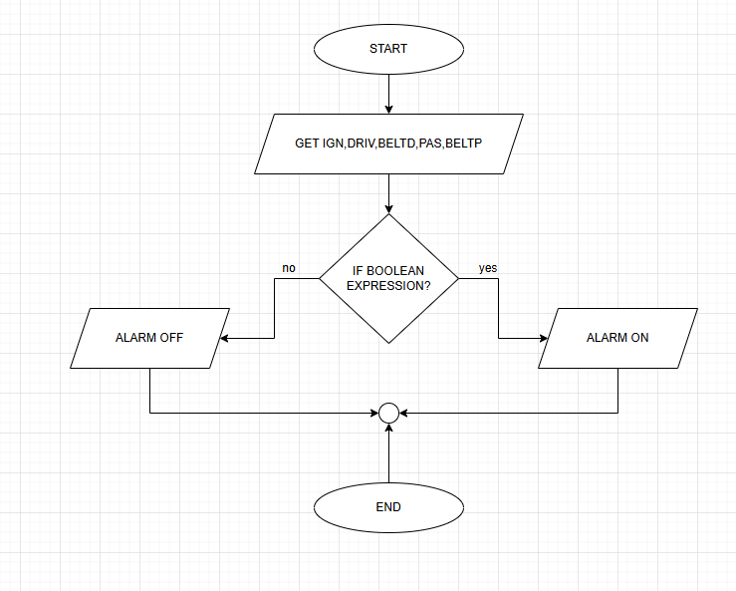
3.5 Pseudocode
START
GET IGN,DRIV,BELTD,PAS,BELTP
IF DRIV. $\underline{BELTD}.$ $\underline{PAS}. \underline{BELTP}$.IGN + DRIV.^BELTD.^PAS.BELTP.IGN + DRIV.^BELTD.PAS.^BELTP.IGN + DRIV.^BELTD.PAS.BELTP.IGN + DRIV.BELTD.PAS.^BELTP.IGN
THEN ALARM = 0 #ON
ELSE ALARM = 1 #OFF
END

Step 4: Test and Refine the Solution (Debug and Verify)
IGN | DRIV | ^BELTD | PAS | ^BELTP | ALARM | OUTPUT
1 | 0 | 0 | 0 | 0 | 1
1 | 0 | 0 | 0 | 1 | 1
1 | 0 | 0 | 1 | 0 | 1
1 | 0 | 0 | 1 | 1 | 1
1 | 0 | 1 | 0 | 0 | 1
1 | 0 | 1 | 0 | 1 | 1
1 | 0 | 1 | 1 | 0 | 1
1 | 0 | 1 | 1 | 1 | 1
1 | 1 | 0 | 0 | 0 | 0
1 | 1 | 0 | 0 | 1 | 0
1 | 1 | 0 | 1 | 0 | 0
1 | 1 | 0 | 1 | 1 | 0
1 | 1 | 1 | 0 | 0 | 1
1 | 1 | 1 | 0 | 1 | 1
1 | 1 | 1 | 1 | 0 | 0
1 | 1 | 1 | 1 | 1 | 1

Part 3: Implementing the Solution
